**Redditch Cycle Challenge**

Here is: **Martin Lewis** (MJL1975) who regularly commutes a long way and enjoys the newly upgraded facilities at work and likes to keep his bike in the office along with the other 'furniture'.

* **When did you start cycling?**

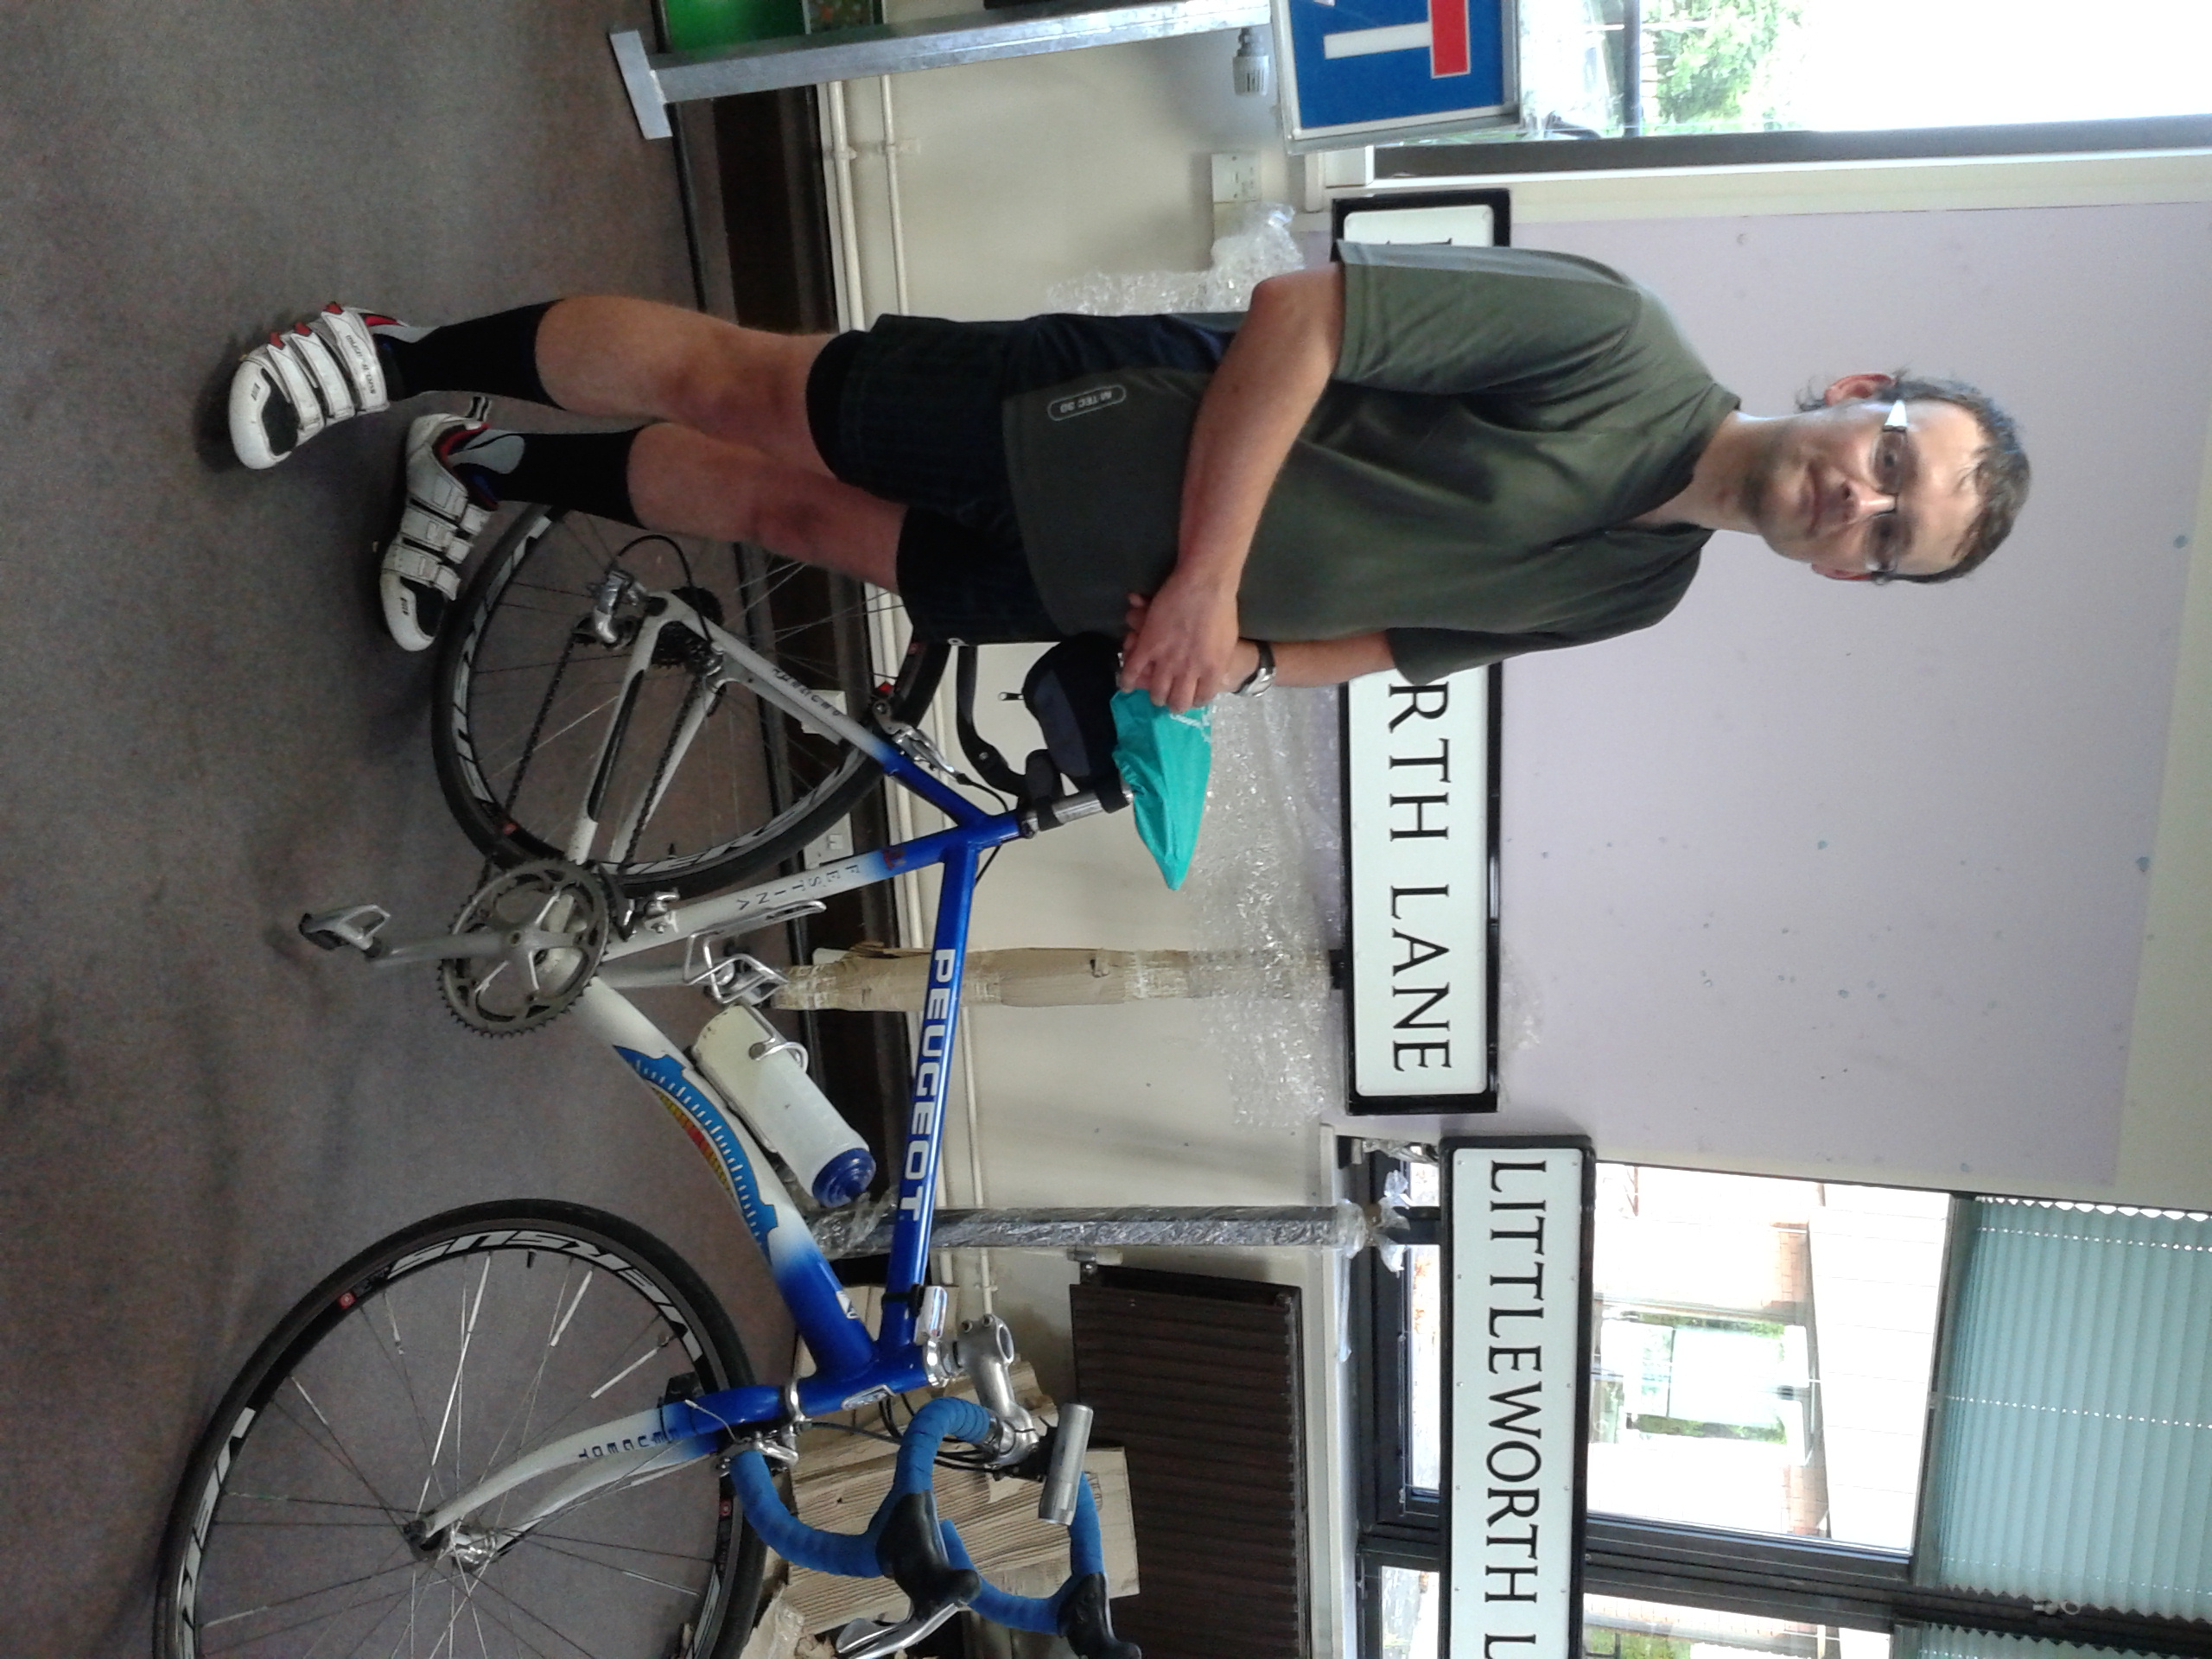

* *I was probably 3 or 4 years old. Most photos from then have got me and a bike in them. I had a Raleigh Tomahawk and I remember the Milk Race which was all Raleigh. I’m a bit of a Peugeot bike fan; I've had a Peugeot Mountain Bike since I was 14. This bike is a 1996 Peugeot Festina which is mid-range spec compared to nowadays. There were doping allegations around the Tour de France teams at the time and the bikes which were unsold were scrapped. I got this one a couple of years ago.*
* **What types of journey do you do?**
* *As you know, I cycle to work which is Worcester to Redditch. I don't ride on that road during winter. I ride with Worcester Cycling Touring Club on Thursday evenings and Saturdays we're out all day. We tend to ride from café to café.*
* **Do you cycle all year round and what's your average annual mileage?**
* *I ride in all weathers, mainly on the road. I have two sets of wheels (and tyres) for summer and winter for the road bike. The triple Kevlar reinforced tyres are great in the winter – puncture resistant! I've done over 2500 miles so far this year.*
* **Who do you ride with?**
* *I ride with Worcester and Malvern CTCs. There's a good mix of riders between 20 and 86 years of age and anywhere between 2 and 30 riders go out. It's a well-established charity with its own insurance and incident line so lots of support. I commute on my own. Worcester to Redditch is 17.6 mile. Today I averaged 13 miles per hour and burned 865 calories.*
* **Describe your favourite route?**
* *I like riding around the Malvern Hills. The views across to Hereford are stunning. I grew up there so I'm biased.*
* **What do you enjoy about cycling?**
* *The freedom! You don't get stuck in traffic jams. Also, I had an accident years ago when I*

*was a child which means I can't do many sports because of my knees and I don't like swimming so I cycle. My colleagues say I'm always eating, I do eat healthily, lots of fruit.*

* **What would you say to encourage others to cycle?**

*Start small. Don't have ambitious targets just 2 or 3 miles then before you know it you’ll be doing 50 miles. It's mad to go straight to 60 or 100 miles, it'll be too much then you won't bother doing it again. Also you need a bike that fits you properly, that's very important. Padded shorts help with comfort (especially for the longer rides, energy drinks and bars will keep you going when you're on a long ride. Jelly babies are the best!*

* **How do you keep your bike roadworthy and do you do your own cycle maintenance?**
* *I don't think it's difficult to do the basics: keep your wheel rims clean; check brake blocks; wipe WD40 on cables; keep chain and cassette clean and make sure the wheels are tight. Use a local bike shop and build a relationship with them – you can’t beat the service normally.*
* **How did you hear about the Redditch Cycle Challenge?**
* *I saw the poster right by the door in the Town Hall, it's in a good spot.*
* **Did you see the Tour Series Cycle Event?**
* *I watched the opening ceremony and some of the community races but I couldn't stay longer unfortunately. I did record it and watched it later on Euro Sport.*

Thank you

[www.redditchcyclechallenge.co.uk](http://www.redditchcyclechallenge.co.uk)

